**ASSIGNMENT-3**

**PROGRAM-1**

**LINEAR SEARCH:**



**OUTPUT:**

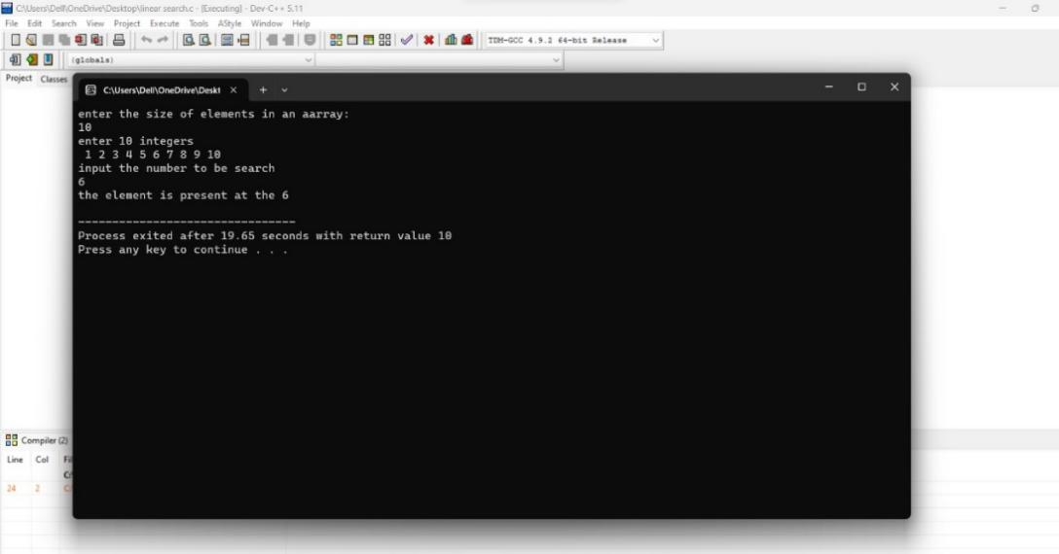

**OUTPUT-2:(ELEMENT NOT PRESENT IN THE LOCATION)**

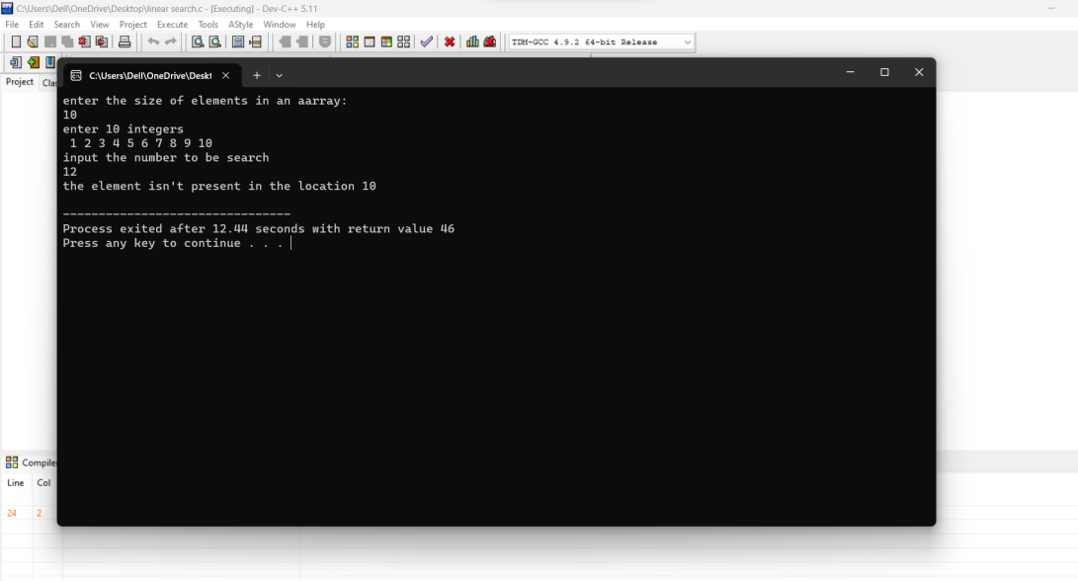

**PROGRAM-2**

**BINARY SEARCH:**



**OUTPUT:**

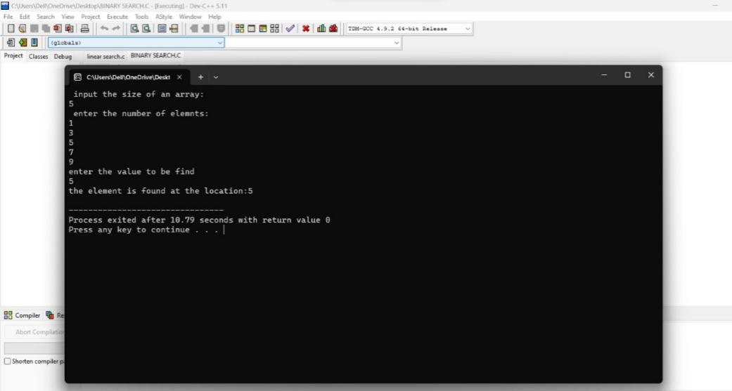

**OUTPUT-2(ELEMENT NOT FOUND AT THE LOCATION)**

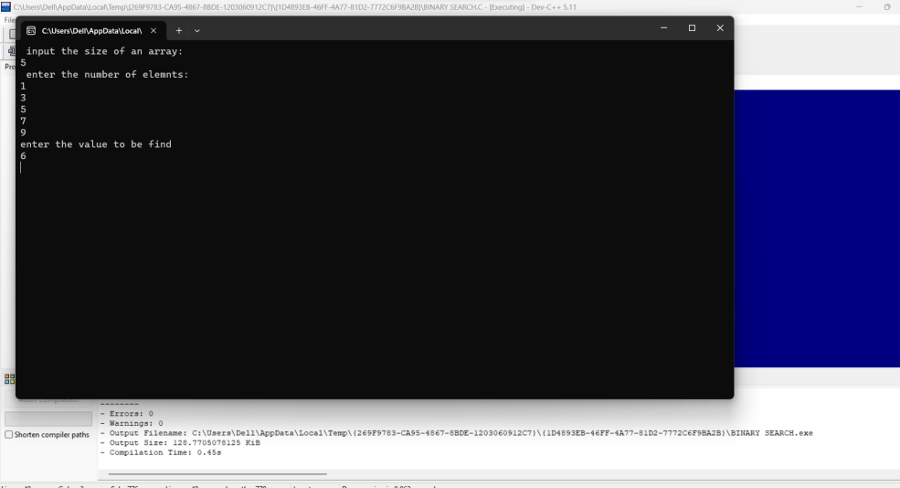

**THE END**